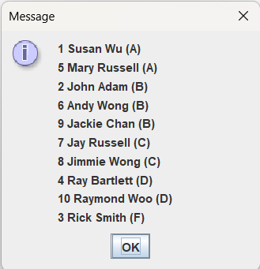
package as06;
import java.util.StringTokenizer;
import javax.swing.JOptionPane;

public class TestStudent {
public static void main(String[] args) {
String in;
int nStudents, nExams;

in = JOptionPane.showInputDialog("Enter number of students");
nStudents = Integer.parseInt(in);

// Create an array of nStudents references
Student[] st = new Student[nStudents];

// Create nStudents objects using loop
for (int i = 0; i < st.length; i++) {
// Input one student data
in = JOptionPane.showInputDialog(
"Enter one student data with items separated by commas");

// Tokenize student data using StringTokenizer
String delim = ",";
String token;

// Create StringTokenizer and supply it with String in and String delim
StringTokenizer stk = new StringTokenizer(in, delim);

token = stk.nextToken().trim();
int id = Integer.parseInt(token);

String name = stk.nextToken().trim();

token = stk.nextToken().trim();
nExams = Integer.parseInt(token);

// create the array scores
double[] scores = new double[nExams];

// populate the array scores
for (int j = 0; j < nExams; j++) {
token = stk.nextToken().trim();
scores[j] = Double.parseDouble(token);
}

// Create a Student object with the above data
st[i] = new Student(id, name, scores);
}

// Find student grades and display output

// Create an empty output String for each type of grade
String outA = "", outB = "", outC = "", outD = "", outF = "";

// find student grades and accumulate output for each type of student
String grade = "";
for (int i = 0; i < st.length; i++) {
grade = st[i].findGrade();
if (grade.equalsIgnoreCase("A")) {
// accumulate output in outA for A students
outA = outA + st[i].getId() + " " + st[i].getName() + " (" + grade + ")\n";
} else if (grade.equalsIgnoreCase("B")) {
// accumulate output in outB for B students
outB = outB + st[i].getId() + " " + st[i].getName() + " (" + grade + ")\n";
} else if (grade.equalsIgnoreCase("C")) {
// accumulate output in outC for C students
outC = outC + st[i].getId() + " " + st[i].getName() + " (" + grade + ")\n";
} else if (grade.equalsIgnoreCase("D")) {
// accumulate output in outD for D students
outD = outD + st[i].getId() + " " + st[i].getName() + " (" + grade + ")\n";
} else {
// accumulate output in outF for F students
outF = outF + st[i].getId() + " " + st[i].getName() + " (" + grade + ")\n";
}
}

// concatenate strings
String outAll = outA + outB + outC + outD + outF;

// display output
JOptionPane.showMessageDialog(null, outAll);
}
}

